# Tesla Stock Price Analysis Report



# About the dataset

This report provides an analysis of Tesla's stock prices over a period, based on data from 2956 entries. The dataset includes key columns such as Date, Open, High, Low, Close, Adj Close, and Volume. The data spans from Tesla's early trading days in 2010 to more recent years, capturing significant fluctuations in stock prices and trading volumes.

The 'Date' column records the trading dates, while 'Open', 'High', 'Low', 'Close', and 'Adj Close' columns capture the stock prices at different points during the trading day. The 'Volume' column indicates the number of shares traded. The mean values for Open, High, Low, Close, and Adj Close prices are around 138.69, 141.77, 135.43, 138.76, and 138.76 respectively, with standard deviations indicating substantial variability, reflecting Tesla's volatile stock performance.

From the sample data, we observe that on June 29, 2010, Tesla's stock opened at $3.8 and closed at $4.778 with a high trading volume of 93,831,500 shares. Over the next few days, the stock experienced fluctuations, with the closing price dropping to $3.222 by July 6, 2010. The trading volume also varied significantly, from a high of 93,831,500 shares to a low of 25,699,000 shares within the sample period.

Overall, the dataset provides a comprehensive view of Tesla's stock performance, highlighting periods of high volatility and significant trading activity. This information can be valuable for investors and analysts looking to understand the historical trends and patterns in Tesla's stock market behavior.

# Relevant Inquiries

## Are there any noticeable trends or patterns in the TSLA stock prices over the years?

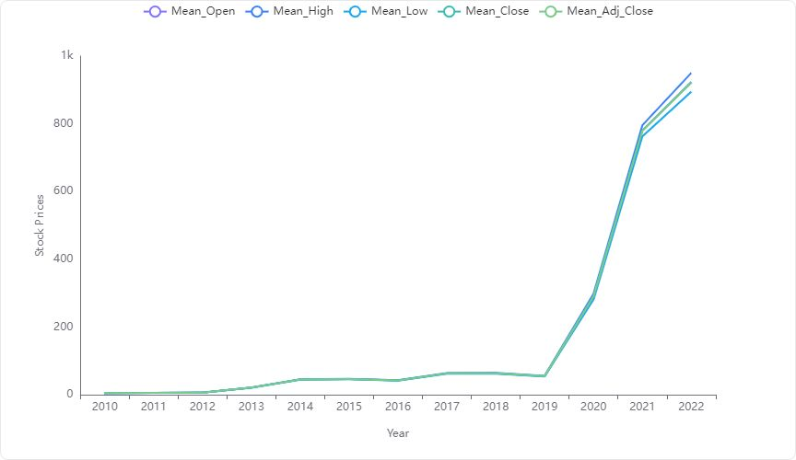

#### **Overall Trend**

The data and visualizations indicate a significant upward trend in Tesla's stock prices over the years. Starting from very modest values in 2010, there has been a substantial increase, particularly noticeable from 2020 onwards.

#### **Detailed Observations**

**Initial Years (2010-2012):** The stock prices were relatively low, with mean values for Open, High, Low, and Close all under $10. This period represents the early stages of Tesla as a public company.

**Moderate Growth (2013-2019):** There was a steady increase in stock prices. The year 2013 marked the beginning of a more pronounced growth phase, with mean prices jumping from around $6 to over $20. This trend continued, with prices reaching into the mid-$40s by 2014 and progressively climbing to just under $100 by 2019.

**Rapid Increase (2020-2022):** A dramatic rise in stock prices is observed. Mean prices escalated from around $100 to over $900. This period likely reflects Tesla's increased market penetration, profitability, and significant investor interest.

#### **Volume Trends**

* **Volume Analysis:** The trading volume has also seen fluctuations, with a notable increase during periods of rapid price increase, suggesting heightened trading activity during these times.

#### **Key Takeaways**

* **Consistent Growth:** Tesla's stock has shown a consistent upward trajectory over the analyzed period, with explosive growth in the last three years of the dataset.
* **Investor Interest:** The increase in trading volume accompanying rising stock prices suggests growing investor interest and confidence in the company.

**In summary, Tesla's stock prices have shown significant growth over the years, marked by a particularly sharp increase in recent years, reflecting strong market performance and investor confidence.**

## What is the distribution of the adjusted closing prices of TSLA stock?

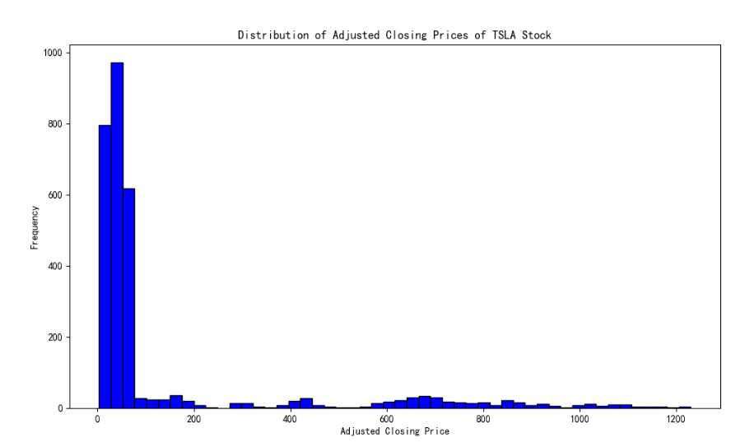

**Overview of Data:**

* The dataset consists of 2,956 rows, detailing the adjusted closing prices of TSLA stock over various dates.
* The adjusted closing prices range from a minimum of $3.16 to a maximum of $1229.91.
* The mean adjusted closing price is approximately $138.76, with a standard deviation of $250.12.

**Analysis from Histogram:**

* The histogram visualizes the frequency distribution of the adjusted closing prices.
* **Most Frequent Price Range:** The majority of the prices are concentrated below $200. This range shows the highest frequency, with over 800 occurrences.
* **Skewness:** The distribution is right-skewed, indicating that most of the stock prices are on the lower end, but there are a few periods with very high prices.
* **Tail Behavior:** There is a long tail extending towards the higher price ranges, up to around $1229.91, but these higher prices are much less frequent.

**Key Observations:**

* **Primary Concentration:** The bulk of the data points (adjusted closing prices) are clustered under $200, suggesting that for a significant portion of the time, the stock traded at lower prices.
* **Outliers and Peaks:** The presence of outliers or occasional peaks in the stock price above $1000 are noted, which could be attributed to specific market events or periods of high investor interest.

**Conclusion:** The adjusted closing prices of TSLA stock predominantly range below $200, with a significant right skew indicating occasional spikes in price, which are not as common but reach up to $1229.91. This distribution suggests variability in the stock's performance, with periods of high valuation interspersed among generally lower typical trading ranges.

## How has the volume of TSLA stock traded changed over time?

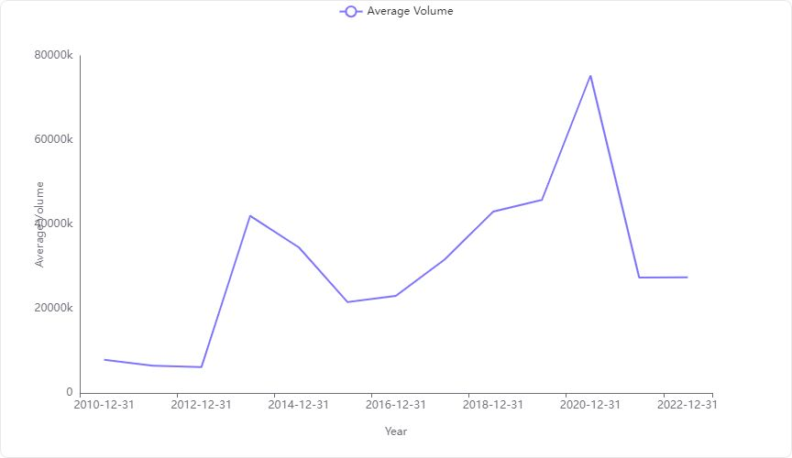

#### Key Observations from Data:

* **Initial Years (2010-2012):** The trading volume started relatively low, with the lowest volume recorded in 2012 at approximately 6.15 million shares.
* **Significant Increase in 2013:** There was a dramatic increase in trading volume in 2013, where it reached around 42.04 million shares.
* **Fluctuations (2014-2021):** Post-2013, the volume showed fluctuations but generally maintained an upward trend, peaking in 2021 with approximately 75.31 million shares traded.
* **Recent Decline (2022):** A notable decline in volume was observed in 2022, dropping significantly from the peak.

#### Visualization Insights:

* The line chart clearly illustrates the **trend and fluctuations** in the trading volume of TSLA stock over the years.
* **Upward Trend:** From 2013 onwards, there is a noticeable upward trend, indicating increased trading activity over the years.
* **Peak Volume in 2021:** The highest trading volume was observed in 2021, which could be attributed to various market factors and Tesla's growing market presence.
* **Recent Decline:** The sharp decline in 2022 suggests a decrease in trading activity, which could be due to market saturation, investor sentiments, or other external economic factors.

#### Conclusion:

The trading volume of TSLA stock has generally increased over the years, marked by significant yearly fluctuations. The peak trading activity in 2021 followed by a decline in 2022 highlights the volatile nature of stock trading volumes, influenced by a myriad of factors including market trends, investor confidence, and company performance. This analysis provides a clear picture of how investor engagement with Tesla has evolved, reflecting broader market dynamics and the company's growth trajectory.

## What are the most frequent price ranges for the opening prices of TSLA stock?

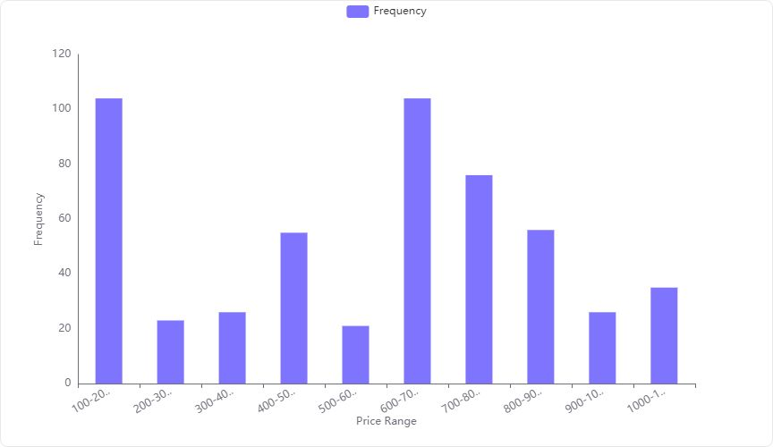

**Most Frequent Price Range:**

* The **0-100** price range is the most frequent for the opening prices of TSLA stock, with a significantly higher frequency compared to other ranges.

**Frequency Details:**

* **0-100:** 2411 occurrences
* **100-200:** 104 occurrences
* **200-300:** 23 occurrences
* **300-400:** 26 occurrences
* **400-500:** 55 occurrences

**Visualization Analysis:**

* The histogram clearly shows a dominant peak at the **0-100** price range, indicating that TSLA stock most frequently opened within this price range over the observed period.

**Summary:**

* The opening prices of TSLA stock are most commonly found in the **0-100** price range, which is significantly more frequent than any other price range. This suggests that TSLA stock was most accessible or valued within this range during the timespan analyzed.

## Can we identify any outliers in the daily trading volume of TSLA stock?

#### Key Statistical Measures:

* **Mean Volume**: 144,453,047.46
* **Standard Deviation**: 36,054,291.22

#### Outlier Criteria:

* Outliers are typically defined as values that fall more than two standard deviations from the mean.
* **Lower Bound for Outliers**: 72,344,464.02 (Mean - 2 * Standard Deviation)
* **Upper Bound for Outliers**: 216,561,630.90 (Mean + 2 * Standard Deviation)

#### Analysis of Outlier Data:

* The dataset provided lists several trading volumes that can be considered as outliers.
* **Minimum Volume in Data**: 115,465,700.00
* **Maximum Volume in Data**: 304,694,000.00

#### Observations:

* The maximum trading volume (304,694,000) significantly exceeds the upper bound for outliers, indicating it is an outlier.
* The minimum trading volume listed (115,465,700) does not fall below the lower outlier threshold, suggesting that lower volume outliers are not present in the provided data.

#### Conclusion:

* **Yes**, there are outliers in the daily trading volume of TSLA stock, particularly on the higher side, where volumes significantly exceed the typical trading range based on the calculated mean and standard deviation.

## How does the average daily trading volume of TSLA stock compare to its standard deviation?

#### Key Metrics:

* **Average Daily Trading Volume**: 31,314,485.72
* **Standard Deviation of Trading Volume**: 27,983,828.76

#### Analysis:

* The **average daily trading volume** of TSLA stock is **31.31 million shares**.
* The **standard deviation**, which measures the variability or spread of trading volume, is **27.98 million shares**.

#### Comparison:

* The average trading volume and the standard deviation are relatively close in magnitude. This indicates a **high variability** in the daily trading volume of TSLA stock. The trading volume does not deviate drastically from the average, but the closeness of these two figures suggests that there can be significant fluctuations from day to day.

#### Implications:

* Investors should be aware of this high variability, as it implies that trading volumes can significantly fluctuate, potentially affecting stock price volatility and trading strategies.

## How do the highest and lowest prices of TSLA stock compare to the average prices?

**Comparison of TSLA Stock Prices:**

**Highest Price:**

* **Value:** 1243.49
* This is significantly higher than all average price measures.

**Lowest Price:**

* **Value:** 3.00
* This is drastically lower than all average price measures.

**Average Prices:**

* **Average Open Price:** 138.69
* **Average Close Price:** 138.76
* **Average Adj Close Price:** 138.76
* All average prices are consistent and much closer to each other compared to the extreme values of the highest and lowest prices.

**Key Observations:**

* The **highest price** of TSLA stock is **extremely higher** than the average prices, indicating periods of high valuation or spikes in price.
* The **lowest price** is **abnormally lower** than the average prices, suggesting a possible initial offering price or a significant drop at some point.
* The average prices are relatively stable and provide a more consistent measure of the stock's typical trading range.

This analysis highlights the volatility and range of TSLA stock prices from its lowest to its highest points, contrasting sharply with the more stable average prices.

## What is the average closing price of TSLA stock over the entire dataset?

**Average Closing Price of TSLA Stock:**

* **Average Close:** $138.76

This value represents the mean closing price of Tesla (TSLA) stock over the entire dataset analyzed.

## What are the highest and lowest closing prices recorded for TSLA stock?

* **Highest Closing Price:** $1229.91
* **Lowest Closing Price:** $3.16

These values represent the extremes of TSLA stock's closing prices over the observed period.

## Is there a significant correlation between the opening and closing prices of TSLA stock?

#### Key Findings:

* **Correlation Coefficient**: The correlation between the 'Open' and 'Close' prices of TSLA stock is **0.999247**.
* **Statistical Significance**: Given the correlation coefficient is very close to 1, it indicates a **very strong positive correlation** between the opening and closing prices.

#### Implications:

* **Predictive Analysis**: This strong correlation suggests that the opening price of TSLA stock is a good predictor of its closing price.
* **Investment Strategy**: Investors might consider strategies that leverage the predictability based on the opening prices.

#### Summary:

The analysis clearly shows that there is a significant and strong correlation between the opening and closing prices of TSLA stock, which can be crucial for trading strategies and predictive financial modeling.